Comparison Between the Education System in Judea and Samaria and Israel
Dr. Shaul Arieli
Tamrur Politography Research Group
December 2025

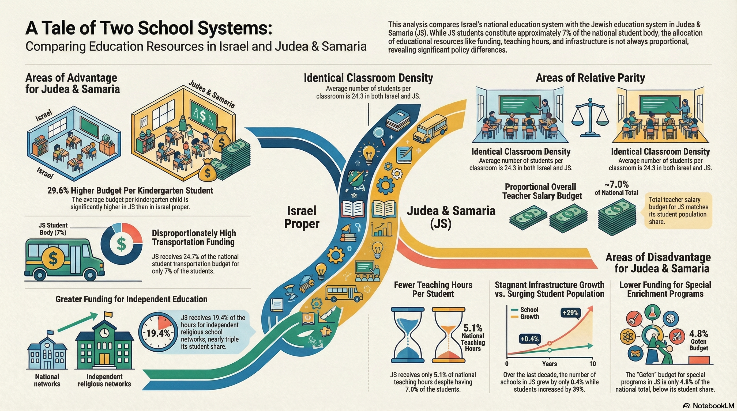

*Translated by Meitar Sorek

Introduction
The Israeli education system provides free compulsory education from age 3 through the end of 12th grade. It operates through four main streams (state, state-religious, independent, and Torah-based) under the supervision of the Ministry of Education and state institutions. In the 2024/25 school year, approximately 2.58 million students were counted in Israel. These students are distributed across 5,807 schools and 21,600 kindergartens throughout the country, in facilities belonging to municipal, regional council, and private education systems. Through military orders, the Ministry of Education is effectively authorized to supervise schools in Judea and Samaria.
Within this context, the areas of Judea and Samaria (JS) include Jewish communities under Israeli civilian administration, and the Jewish education system in these areas is managed by local authorities under the Ministry of Education. A study by the Knesset Research and Information Center indicates that there is no uniform consistency in funding gaps between the education system in JS and the national system. In some indicators, funding in Judea and Samaria is slightly higher than the national average, and in some cases it is lower. This background allows us to thoroughly compare the resources and differences between the two systems. For the basis of comparison, we will use Ministry of Education data, which present key indicators (such as student numbers, teaching hours, budgets, and the like) in both systems through 2024.

Student Numbers and Institutions
According to Ministry of Education data, in 2024 approximately 1.856 million students studied in Israeli schools, while approximately 129.8 thousand students studied in the Jewish education system in JS. In other words, JS students constitute approximately 7.0% of all Israeli students. However, the number of active educational institutions is higher in this ratio. In Israel, approximately 25,303 institutions (schools and kindergartens) operate, while in JS there are 2,157 institutions (approximately 8.5%).
Between 2014 and 2023, an increase of approximately 51% was recorded in the number of classrooms in JS compared to approximately 25% in Israel. This means that JS has more educational institutions per student on average. This phenomenon may stem from the distribution of communities. Many small communities require small schools. Small schools tend to demand higher fixed costs per student (administrator salaries, maintenance, and infrastructure are similar everywhere), and therefore the result may be higher investment per institution in JS. Additionally, small schools allow for higher personal ratios between teachers and students. In summary, although institutions in the JS area are smaller on average, their large number relative to the population supports widespread distribution of schools, and apparently the physical infrastructure is available to every student in remote areas.
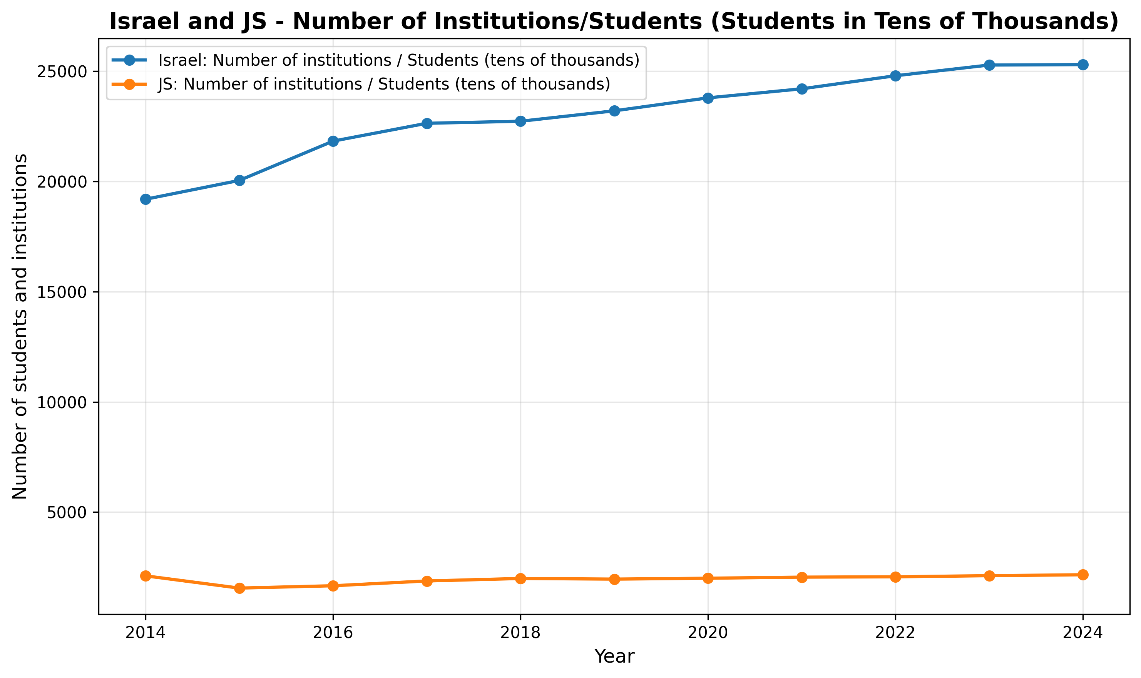

Teaching Hours and Salary Investment
Investment in teaching hours reflects clear gaps between the two systems. In 2024, approximately 3.051 million teaching hours were provided in Israel, while in JS only approximately 156.7 thousand (approximately 5.1% of the national total). Therefore, the relative share of teaching hours in JS is much lower than its percentage of students (5.1% versus 7.0%). This means that each student in JS received fewer teaching hours than the average educational effort in Israel. In contrast, the total salary budget (including supplements) stood at approximately 73.84 billion shekels in Israel and approximately 5.17 billion in JS (approximately 7.0%). In other words, in total summary, the budget per student is more similar to the student share. The gap between teaching hours and salary budget may be explained by the payment mechanism. For example, it is possible that in JS the rate of hours is low because teachers are paid higher salaries or are given many additional hours, which increases the total budget even though the recorded hours are low. Therefore, there is an indication here that the system in JS allocates its resources differently – perhaps fewer formal teaching hours and more additional private hours. In other words, the lack of proportion in hours compared to students hints at a gap in policy (for example, a different teacher profile), and not necessarily overall inferiority of the system.
Conclusion: Contrary to the detailed per-student picture, the overall per-student budget is similar. However, in JS fewer teaching hours per capita are allocated compared to the student percentage (5.1% versus 7.0%), which indicates a difference in salary and time policy – for example, higher salary supplements or numerous additional hours.

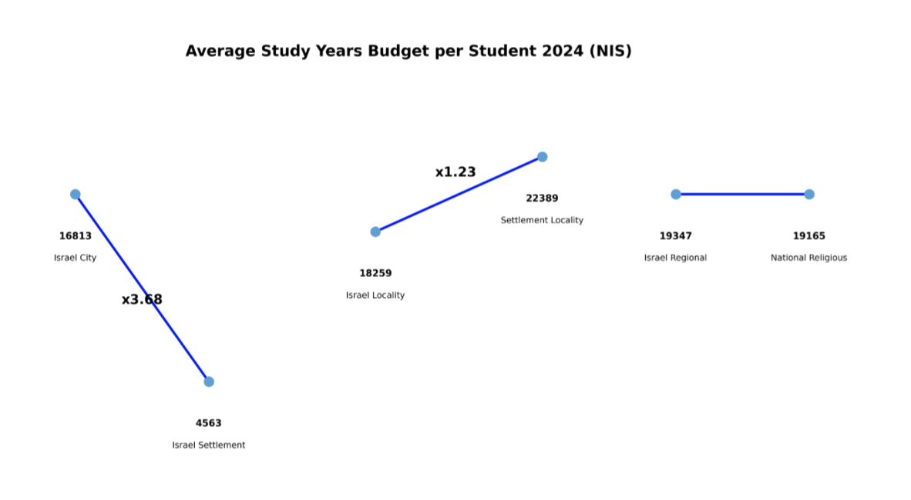Educational Infrastructure (Classrooms and Kindergartens)
In terms of physical infrastructure, the picture is relatively balanced. In 2024, there were approximately 76.29 thousand classrooms in Israeli schools, while in JS approximately 5.334 thousand (approximately 7.0%). The number of kindergarten classes stood at approximately 19.77 thousand in Israel and approximately 1.632 thousand in JS (approximately 8.3%). It follows that student density per classroom is similar between the systems. In Israel, approximately 24.3 students per classroom were recorded on average, and in JS also approximately 24.3 students per classroom. In contrast, in kindergarten classes the average number of children in JS is slightly lower (25 students) than in Israel (26 students). This finding indicates that the dimensions of space and capacity in the education system are similar in percentages between the two systems, and therefore no clear shortage in classrooms or buildings in JS can be seen. It appears that as long as there is no shortage in the number of institutions, this can be regarded as a characteristic of equal physical effectiveness. In summary, kindergarten classes in JS are slightly smaller than the national average – a slight advantage in terms of student-teacher ratio – while classrooms in schools are equally large on average in both systems.
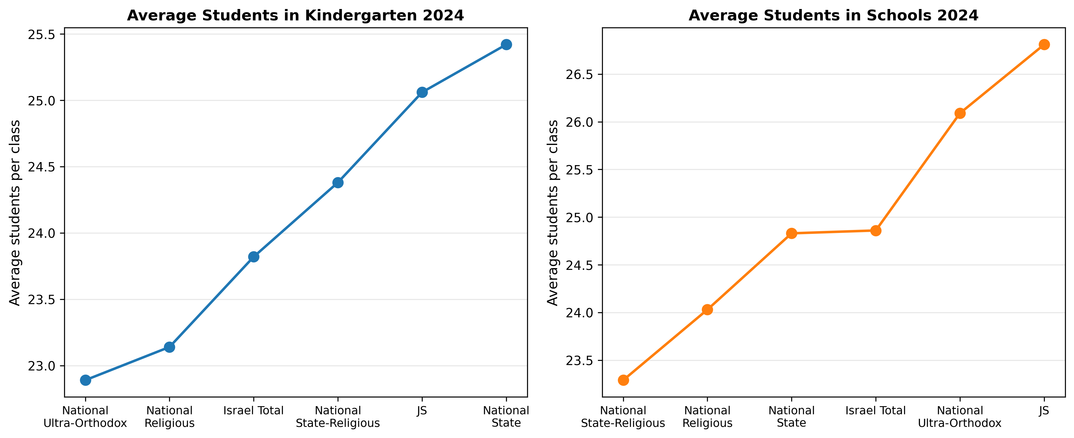

Budgets and Expenditure Per Student
In budget allocation, key gaps were revealed in certain sectors. The average budget per kindergarten-age student is significantly higher in JS: approximately 13,896 shekels per person, compared to approximately 10,720 shekels in the country (higher by approximately 29.6%). This difference indicates relatively generous investment in early childhood education in JS. It is possible that the budgeting policy preferring younger ages in these areas reflects consideration of the population with a smaller volume of young children. In contrast, the GAFAN budget – a government fund for special programs for early childhood – is limited in JS. The total budget in Israel is approximately 2.414 billion shekels, but only approximately 116.6 million shekels were allocated to JS (4.8%). Similarly, the GAFAN budget transferred to authorities stands at approximately 320 million shekels in the country and approximately 23.3 million in JS (7.3%). In summary, JS's share in GAFAN budgets is low relative to its share in students, which indicates deprivation in this area. The general interpretation is that in the early childhood sector, advantages and disadvantages were created. In JS, investment in young children is encouraged (high budget per kindergarten child), but a more moderate approach to special programs (GAFAN) for most students is demonstrated.
Conclusion: The JS system enjoys a larger budget for kindergarten children, but resources for unique educational programs (GAFAN) are significantly limited relative to the number of students.
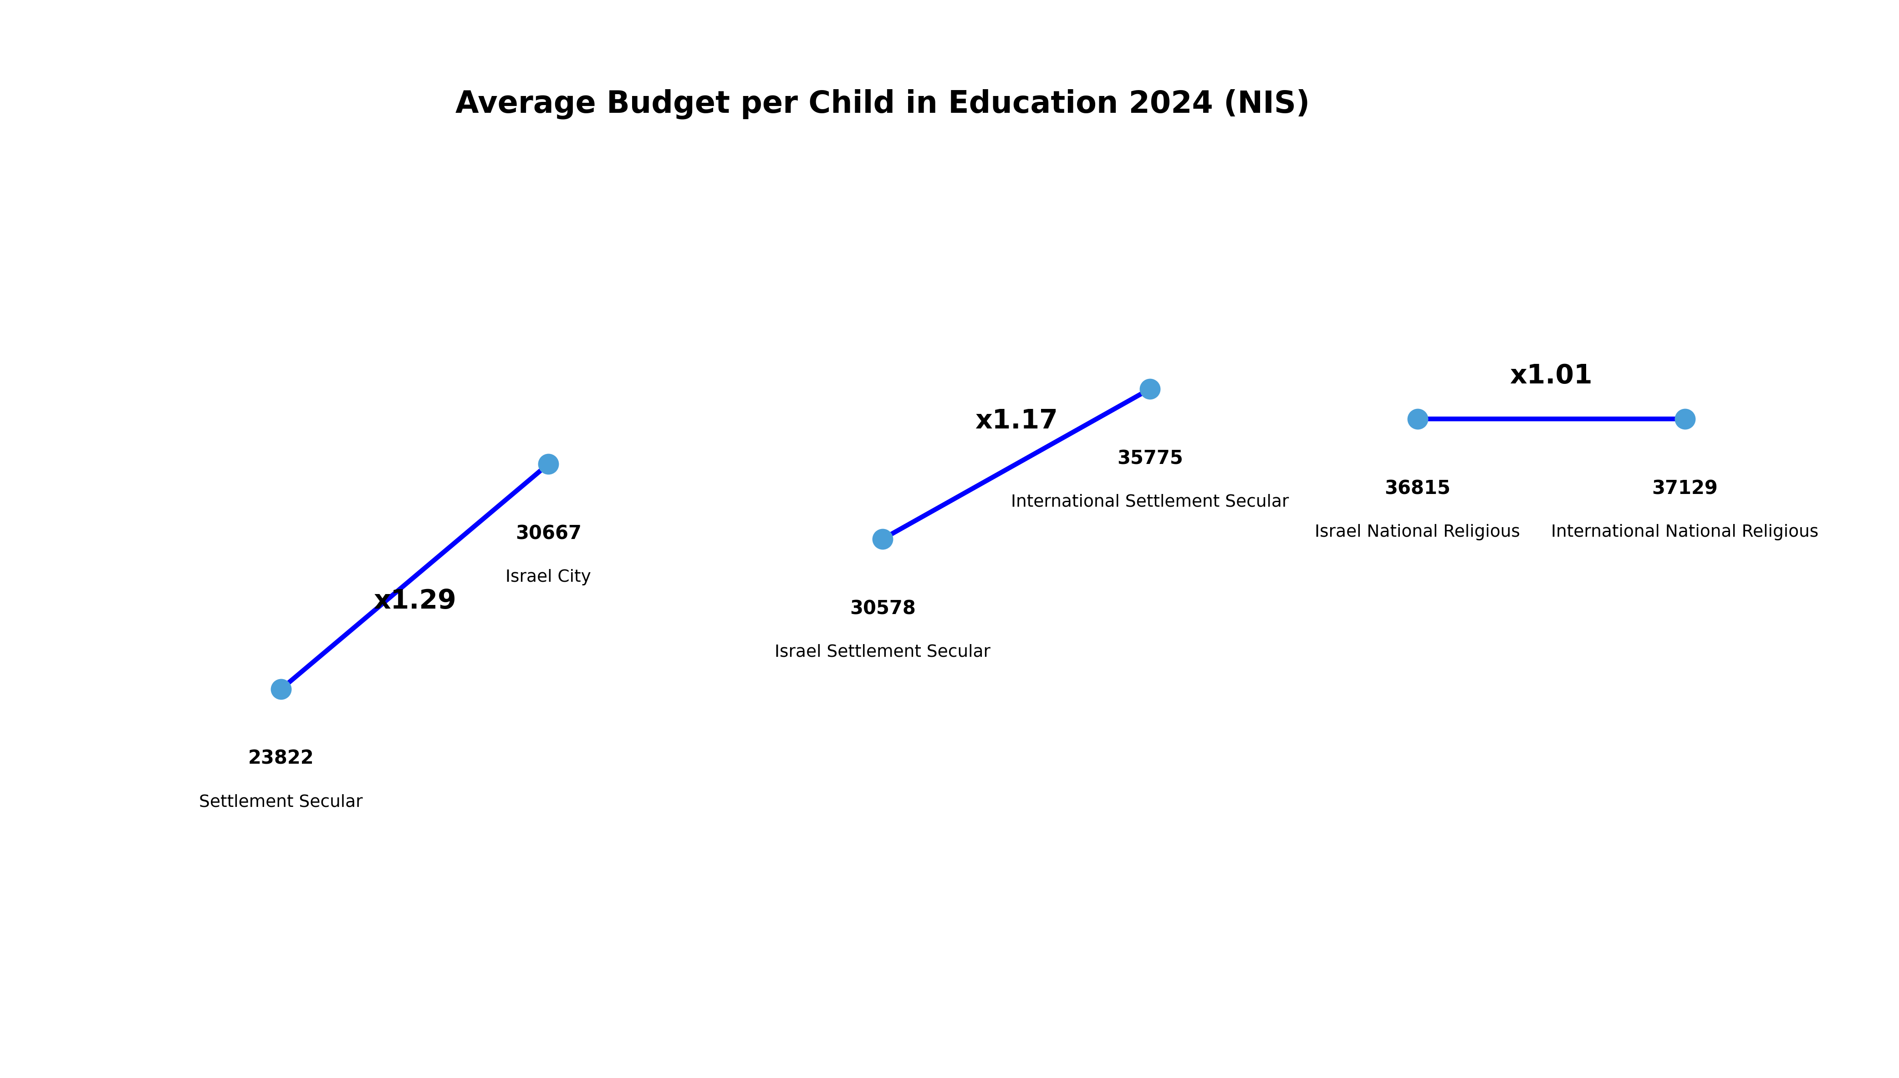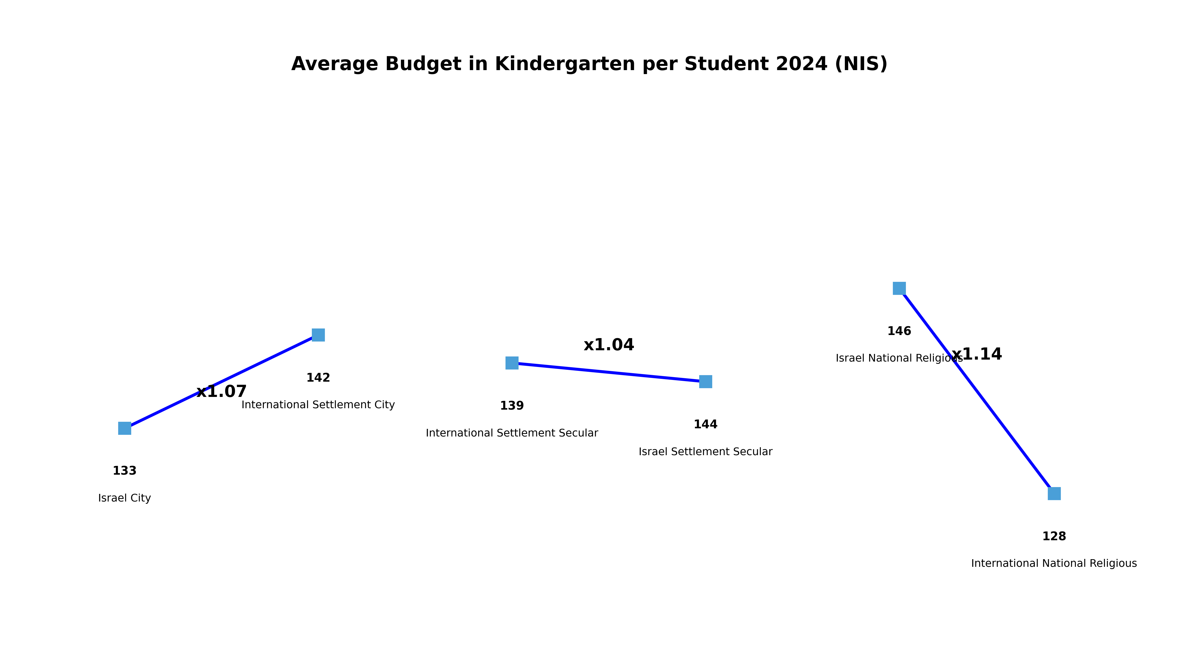

Transportation Services and Independent Education Network
The transportation and independent education sectors point in favor of JS. In 2024, JS's share in the transportation budget stood at approximately 24.7% (approximately 0.522 billion shekels out of 2.116 billion), despite constituting approximately 7% of the students. Such a high percentage indicates significant per-student expenditure for transporting students in this area – apparently due to greater geographical dispersion requiring longer travel distances. Regarding the independent education network (including the Ma'ayan Torah network), 58.65 thousand hours were recorded in JS (19.4% of the national total) at a cost of approximately 0.431 billion shekels. In other words, compared to the student percentage, transportation and independent network hours are funded significantly in JS. This trend indicates allocation of large resources to support logistics and enrichment of education in the social sectors existing in JS.
Conclusion: JS receives relatively high investment in these services beyond its share in students, which apparently reflects budgetary priority for access needs and specific education sectors (for example, ultra-Orthodox and religious) in remote areas. 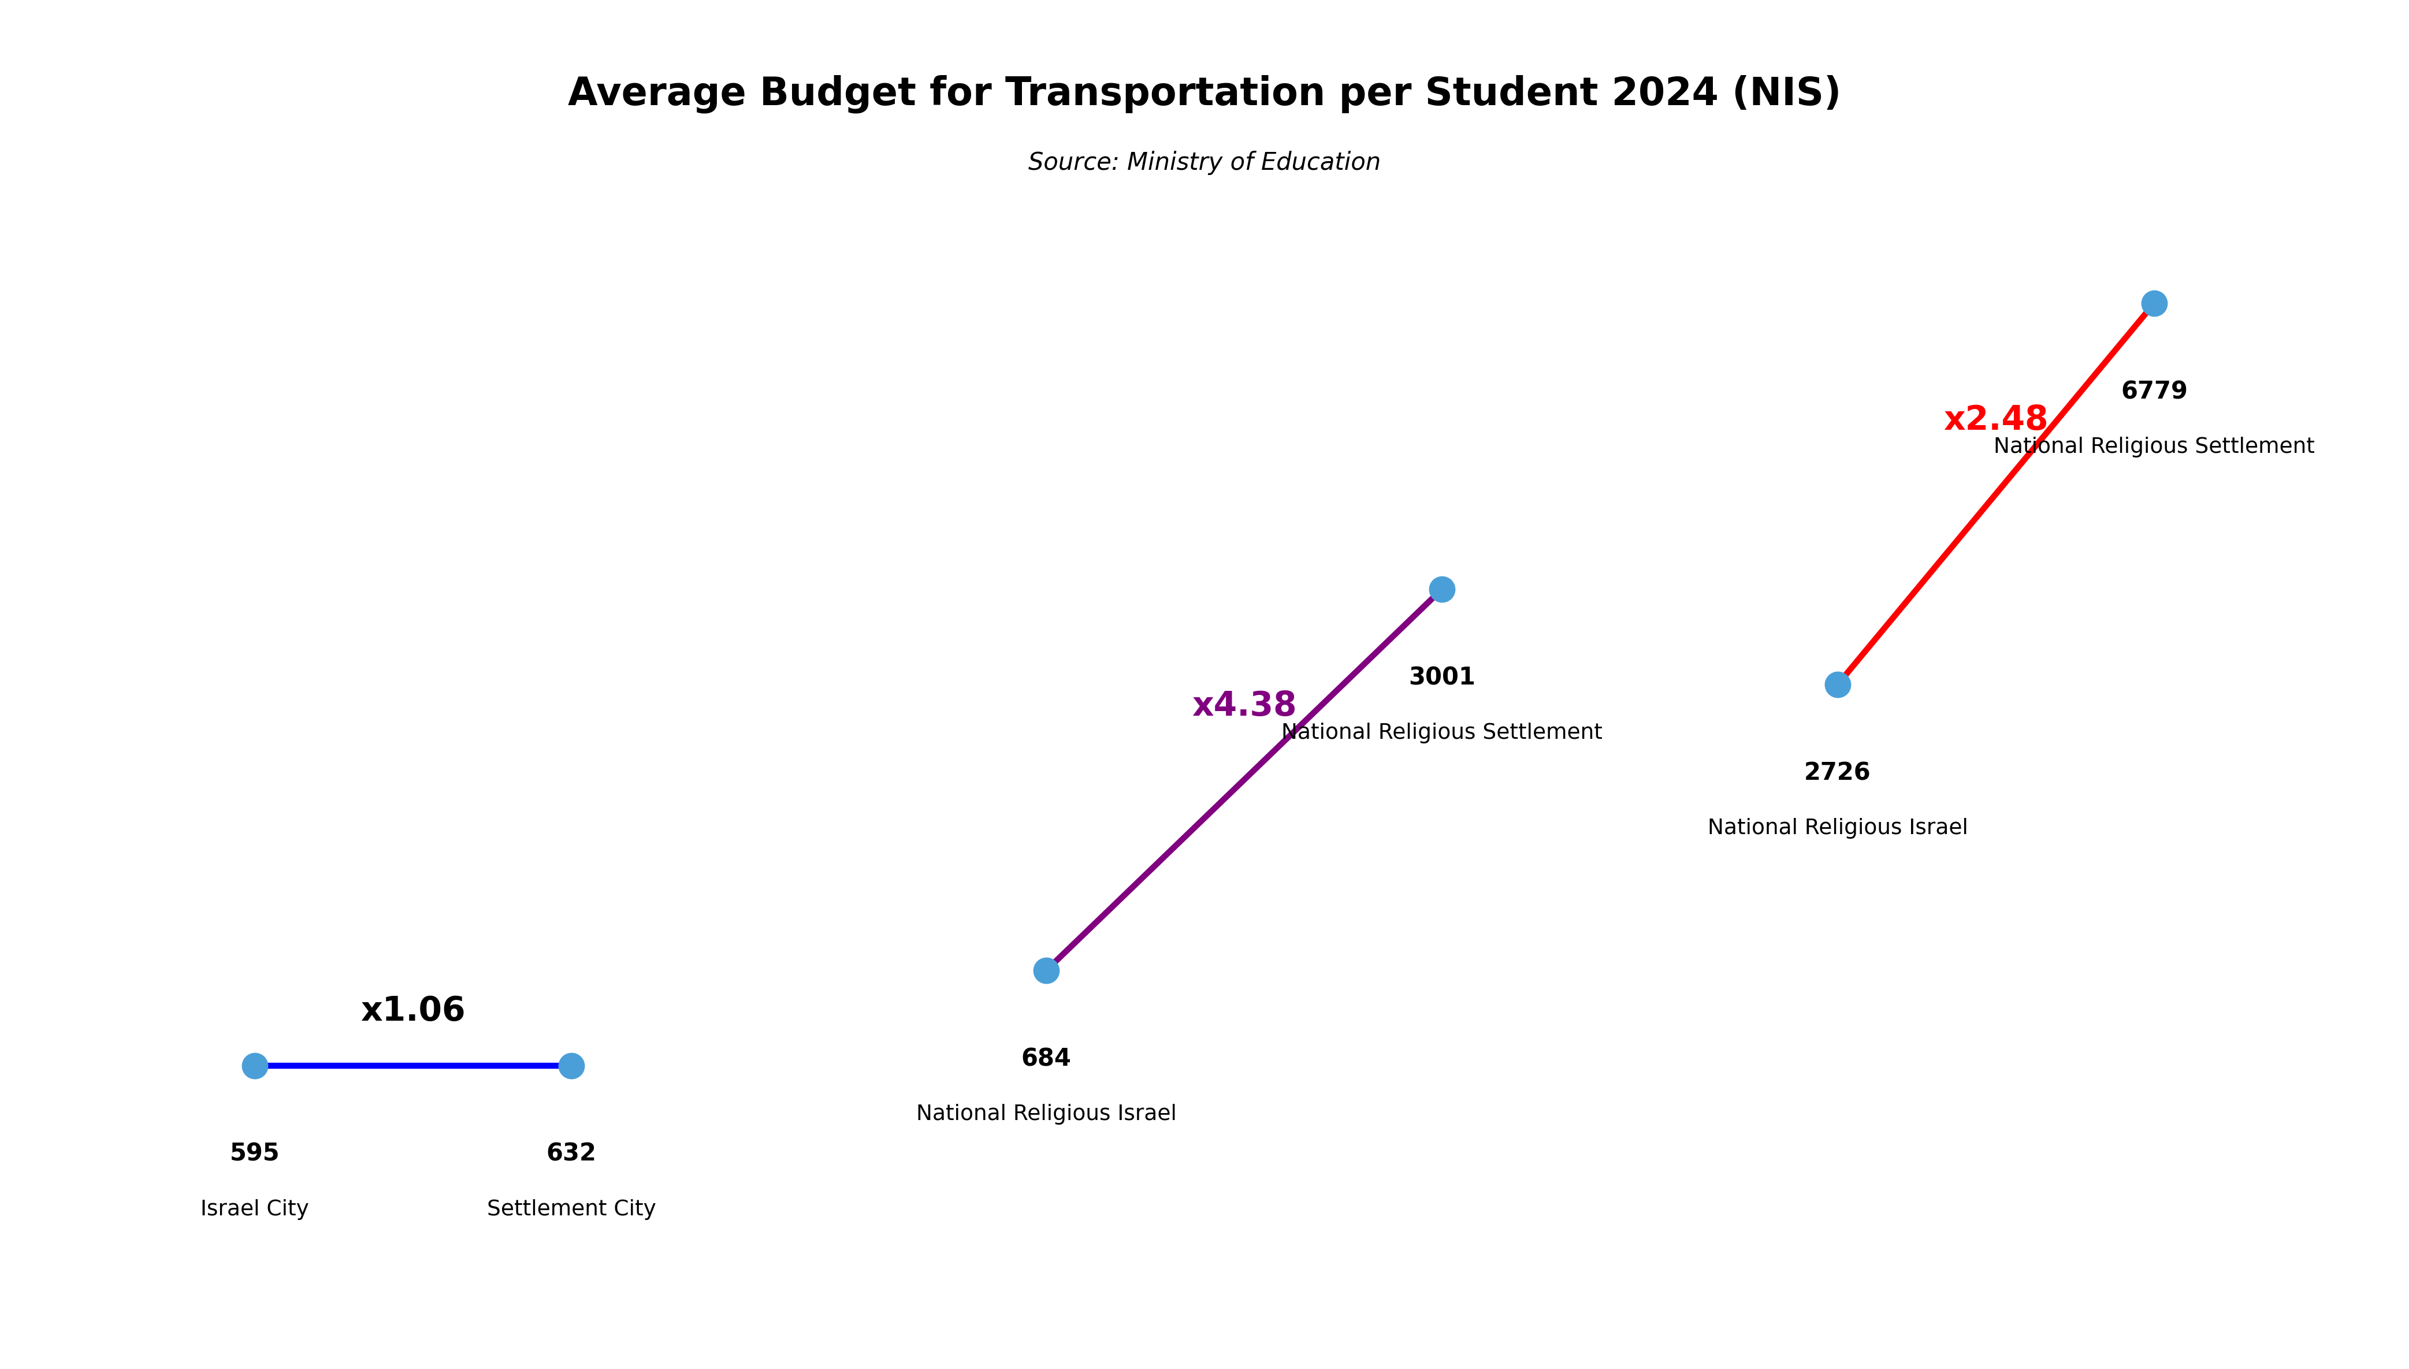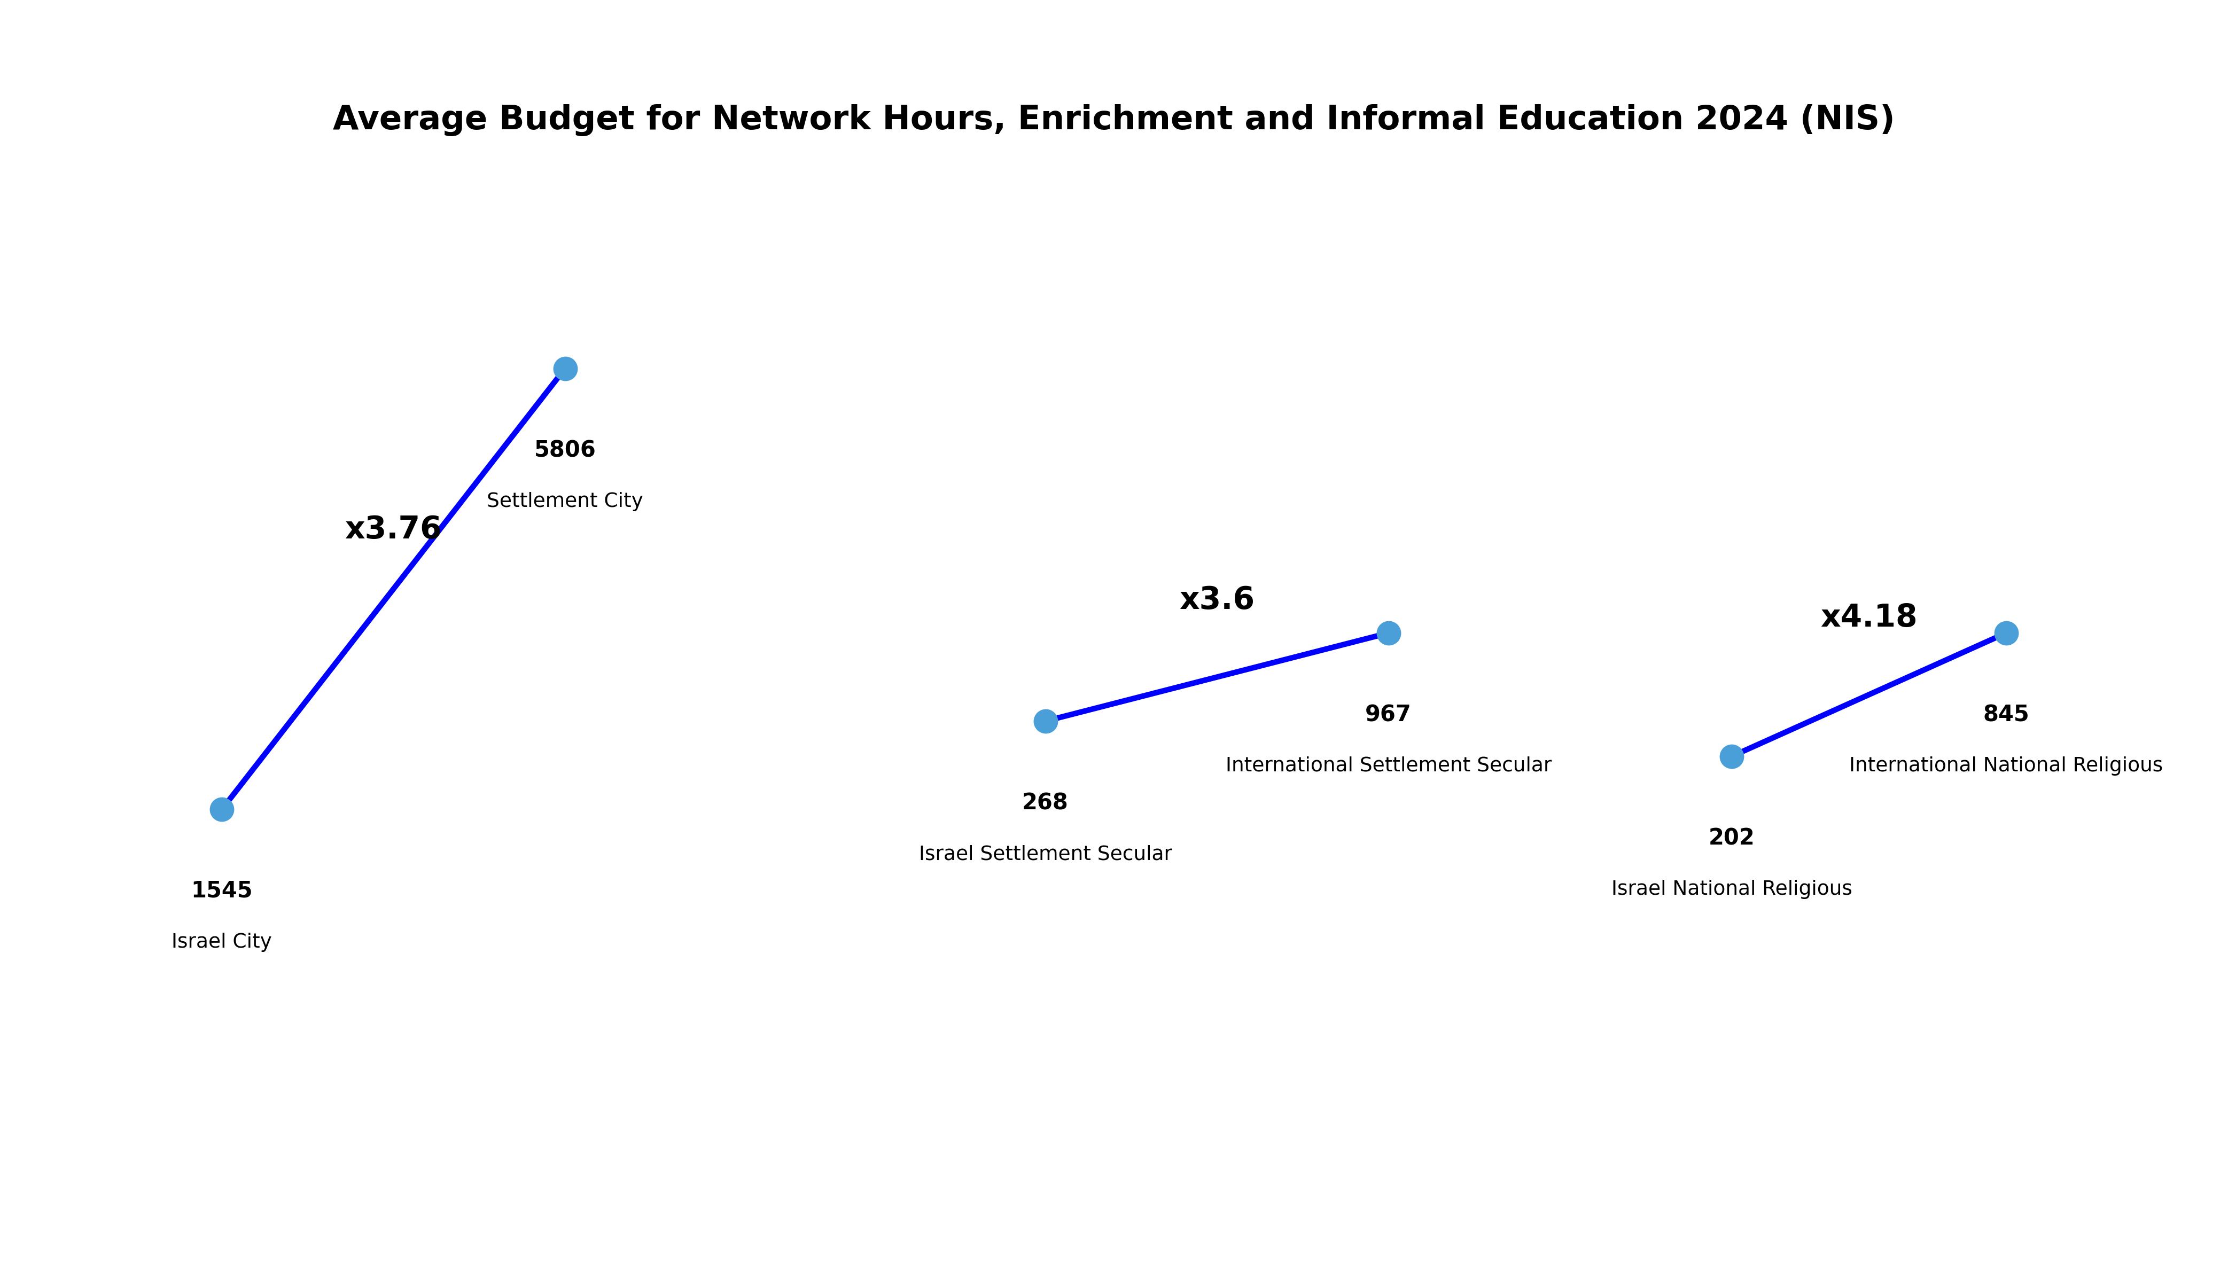

Summary and Conclusions
Relative Equality: Overall, JS's relative share in the allocation of many resources (for example, total salary budgets, number of institutions and classrooms) is close to its student percentage (approximately 7%), which indicates relatively balanced distribution in basic parameters.
Advantages of the JS System: In the early childhood sector and in transportation, JS enjoys particularly high funding. The average budget per kindergarten child is approximately 30% higher than that in the country, and significant transportation budgets (approximately 24.7% of total national transportation) far exceed its share in students. These data indicate budgetary priority in these components for students in Judea and Samaria.
Disadvantages of the JS System: In contrast, JS's share in teaching hours and in GAFAN budgets is low compared to its student percentage. This indicates deprivation in these resources: relatively few teaching hours, and little GAFAN relative to the population. This situation may affect the student-teacher ratio and the availability of improved educational programs.
Equality Incentives: It is recommended to develop special budget programs or grants for institutions in JS (for example, additional teaching hours or population grants) to reduce structural gaps.
Policy Coordination: Formulating inter-ministerial cooperation (Ministry of Education, Ministry of Finance, and local authorities) is important for defining a long-term strategy for equitable educational investment.
Monitoring and Evaluation: It is necessary to continue examining the educational impacts of the gaps – for example, through measuring student achievements – and to use this information for future improvements in budgeting policy.
Achievement Indicators: It is necessary to examine how resource gaps affect student achievements (for example, test results) to improve the alignment between policy and actual education.
In summary, these comparison findings emphasize painful and important points regarding the distribution of education resources. It is clear that every region in the country deserves appropriate investment considering its needs, and therefore all education system stakeholders are required to reconsider priorities. This report emphasizes that in JS there are budgetary advantages in early childhood education and logistical support (transportation), while there is a need to increase resources in areas where deficiencies were identified (for example, teaching hours and special programs). From here, unique solutions must be formulated in places considered deprived, while ensuring transparency and periodic monitoring. At the end of the day, the comparison poses a central question: How will we ensure that every student has the opportunity to realize their potential, regardless of their place of residence? The next budgetary decisions must address these questions practically, to promote genuine equality of opportunity in education and strengthen public trust in the education system.
In summary, it can be seen that the gaps in budget and resources mark central areas for improvement and renewed perspective. All stakeholders in the education system bear the responsibility to ensure that every student – both in the country and in Judea and Samaria – receives the support appropriate for them. This means incorporating dedicated solutions and supports in places where deficiencies were identified, and continuing control and transparency for managing the investment. At the end of the day, this report asks the moral question: How will we ensure equality of opportunity for all students? These findings clarify that the mission goes beyond pure financial balance – values of transparency, public responsibility, and involvement must be promoted. Budget decisions must be reflected in open discussion and periodic monitoring. These findings indicate the importance of continuation and deepening of research, to examine how budgeting trends affect educational achievements in the long term and to help adapt policy to the changing needs of the population. At the end of the day, the central conclusion is that the State of Israel must act deliberately and ensure that resource allocation focuses on equality of opportunity – so that every child can realize their maximum abilities, even if located at the edge of the map. At the end of the day, such analysis can constitute an opening for strengthening social equality and reinforcing public trust in educational institutions.
The comparison data in the file indicate substantial gaps between the education systems in JS and Israel. During the last decade, the number of educational institutions in Israel grew by approximately 32% (from 19,155 in 2014 to approximately 25,284 in 2023), while in JS almost no growth was recorded (approximately 0.4%, from 2,107 to approximately 2,115 in the period). In contrast, the student population in JS rose by approximately 39%, compared to approximately 19% in the rest of the country. As a result, significantly greater burden was created on the system in JS.
In addition, the scope of budgets for education salaries in Israel is much higher than that in JS. In 2023, it stood at approximately 66.5 billion shekels compared to approximately 4.7 billion shekels in JS (approximately 14 times). Budgetary trends also indicate gaps. The total budget for teaching staff salaries doubled in both systems, but the growth rate in JS is higher than that in Israel (approximately 108% versus approximately 84%). However, in terms of budget allocation per student, the allocations are similar in orders of magnitude (approximately 28-29 thousand shekels per student per year in each system). The budgetary emphases are different. For example, the rate of transfers to local authorities for kindergartens is higher per capita in JS, which may indicate an attempt to compensate for deficiencies in local educational infrastructure.
Moreover, in the absence of significant expansion of educational institutions in JS, the number of students per capita in each existing institution increased relatively. Although the number of institutions did not grow, the data indicate that new classrooms were added in existing schools in JS (approximately 51% growth in the number of classrooms versus approximately 25% in Israel). This means that each educational institution absorbed more students in the same infrastructure. The growth of approximately 40% in teaching hours in JS occurred against a background of stagnation in the number of learning institutions, which indicates growing burden and a higher student-teacher average than in Israel. This phenomenon may limit personal attention in each lesson and burden teachers with multiple pedagogical tasks.
From analyzing the data, a central conclusion emerges: the pace of growth in physical infrastructure (classrooms, institutions) in JS is insufficient compared to the pace of increase in student numbers, and this gap must be addressed to prevent harm to teaching quality. From the perspective of balanced education policy, it is necessary to reduce allocation gaps between the systems, by strengthening the education system in JS in a manner that ensures fair and equitable allocation of resources relative to population size and its needs.

Concrete Recommendations for Decision Makers
• Pedagogical Policy: To strengthen the human resource in the area by recruiting and training additional teachers for JS, with the aim of reducing the high student-teacher ratio. It is advisable to offer salary incentives and improved employment conditions for teachers serving in remote schools, and to expand professional training adapted to the population's needs. In addition, flexible study programs should be developed that suit the character of the local community, including implementation of innovative learning technologies supporting teaching processes.
• Infrastructure Policy: To invest in expanding infrastructure in JS according to population growth: establishing kindergartens and new schools in areas with significant growth, and expanding classrooms and equipment in existing schools. It must be ensured that infrastructure planning is based on local demand forecasts, and also to improve secondary infrastructure such as educational transportation and technological facilities, so that efficient and quality teaching is possible in every institution.
• Budgetary Policy: To adjust budget distribution to the number of students and growth rate in each area: to increase JS's education budget in a manner that ensures per-student investment similar to that in the rest of the country, and to ensure continuous budget transfers to local authorities in JS (especially for kindergartens and infrastructure). Special incentives can also be offered, such as salary grants for teachers serving in JS or funds for investment in educational infrastructure, to reduce social gaps and promote equality of opportunity in education.

Proposed Follow-Up Research
• Impact on Academic Achievement: To conduct quantitative research comparing academic achievements (for example, matriculation scores) of students in JS and Israel, to examine whether resource gaps in infrastructure and teaching in JS are expressed in differences in educational outcomes.
• Impact on Dropout Rates: To conduct follow-up research in the education system in JS that examines dropout data and connects them to local system resources (educational institutions, student-teacher ratio, and the like). Thus it will be possible to identify whether the dropout rate is higher in areas where gaps in educational investment are noticeable.
• Equality of Opportunity: To conduct comparative research between education systems by examining academic success of students from similar socio-economic backgrounds in JS and Israel. For example, the rate of matriculation eligibility and continuation to higher education should be examined to assess whether budget gaps encourage or reduce social gaps in opportunities.

